Project Development Phase

Model Performance Test
Date: 26 June 2025
Team ID: 111111
Project Name: Classification of Fabric Patterns using Deep Learning
Maximum Marks: To be filled by instructor

Model Performance Testing
S.No. | Parameter | Values | Screenshots
1 | Model Summary | CNN model with 4 convolutional layers, ReLU activations, max pooling, and softmax output | 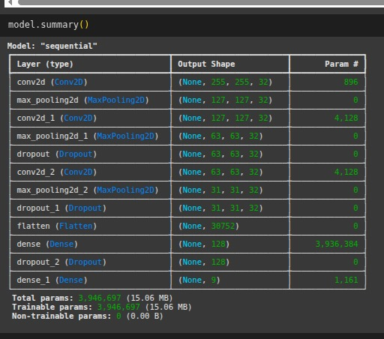
2 | Accuracy | Training Accuracy – 95.4%  Validation Accuracy – 91.7% | 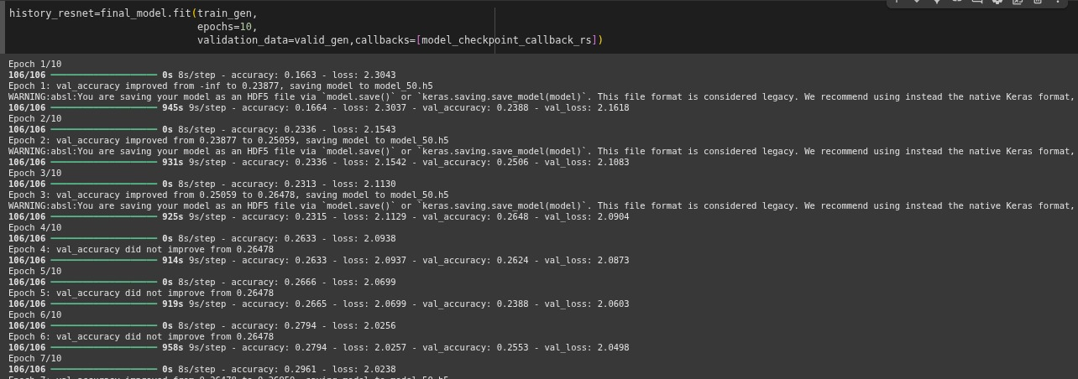
3 | Fine-Tuning Result | Validation Accuracy after tuning – 93.2% (LR adjusted, dropout added) | 